BLOOD SAFETY INDICATOR (BSI)

WEB SITE MANUAL

Approved by:

|  |  |
| --- | --- |
| __________________________________  **Pedrito Y. Tagayuna**  Medical Specialist III  MDFPSP | ___________________________________  **Johnmar P. Garcia**  IT-Officer I  IMU-NVBSP |

1. **Chrome.pngAccessing the NVBSP web sites**
   1. Open your browser preferably

`Google Chrome` to fully support

the features of the web site

* 1. For **NVBSP** web site, type in

The address bar `*home.nbbnets.net*`

* 1. For **NBBNetS** web site, type in

the address bar

` *www.nbbnets.net`*

* 1. For **National Sandugo Awards**

web site, type in the address

bar `*home.nbbnets.net/sandugo*`

* 1. For **World Blood Donor Day** web

site, type in the address bar

`*wbdd2015palawan.com*`

* 1. For **Blood Safety Indicator** web site,

type in the address bar

`*home.nbbnets.net/bsi*`

* 1. Then click **Enter** on the

keyboard

1. **home page icon.PNGAccessing the Home page**
   1. You can view the content of the home page

clicking the Home icon

* 1. 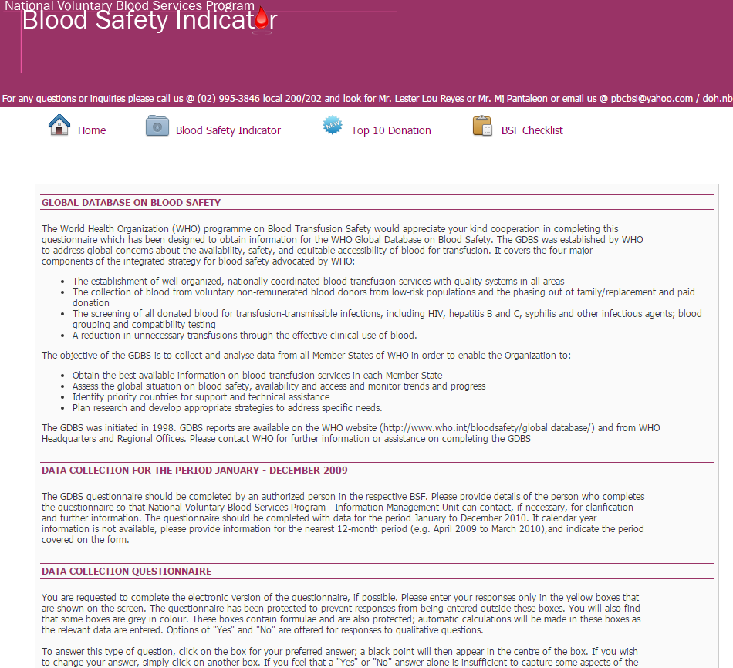Content of the home page

are the following:

Global Database on Blood

Safety, Data Collection

Period, Data collection

Questionnaire instructions

1. **bsi icon.PNGDownloading the Blood Safety Indicator (BSI) worksheet**
   1. you can access the Blood Safety Indicator (BSI)

worksheet by clicking the Blood Safety Indicator

icon

* 1. 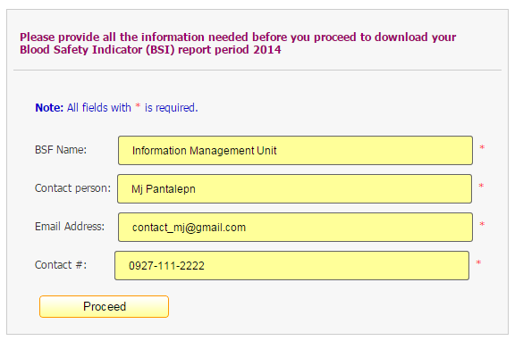to download the Blood Safety Indicator

(BSI) worksheet, just provide the

necessary information needed

bsi proceed btn.PNG

* 1. Then click

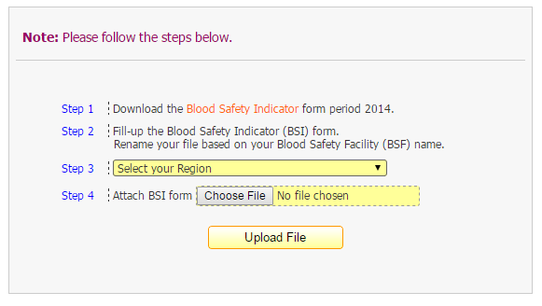

* 1. You will be redirected to this page,

Just follow the instructions

* 1. Download the Blood Safety Indicator

Worksheet by clicking the Blood Safety

Indicator link in Step 1

* 1. Follow Step 2 and Select your Region

in Step 3

* 1. Then attach you accomplished BSI report

by clicking the `*Choose File*`

bsi 2nd step btn.PNG

* 1. Then click

bsi 2nd step - success upload.PNG

* 1. If no error found then you will see

this success message

1. **Accessing Top Ten(10) Blood Safety Facility (based on Total Donation)**
   1. top10 link.PNGTo access the Top 10 BSF

(*based on Total Donation*), click the

Top 10 icon

* 1. The user will see a list of Top 10 Blood Safety Facility (BSF) in their

respected years

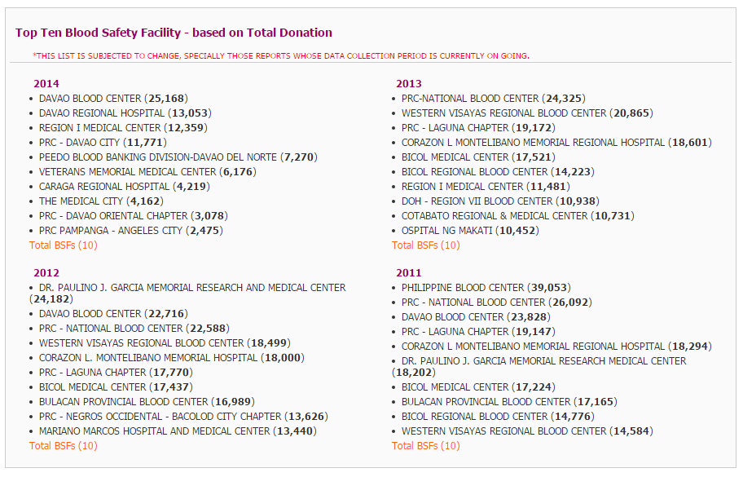

* 1. Note: The list is subjected to change, especially those reports whose data collection period is currently on going

1. **BSF checklist link.PNGBlood Safety Facility(BSF) Checklist**
   1. To access the Blood Safety Facility Checklist,

Click the BSF Checklist icon

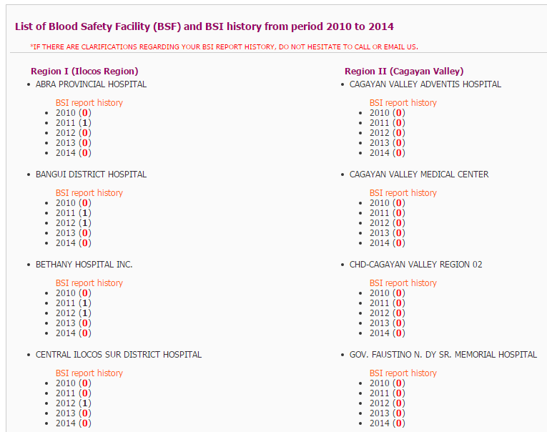

* 1. after click the icon, the user

will see a list of Blood Safety

Facility (BSF) under their

respective *Region* together

With their *Blood Safety*

*Indicator (BSI) report history*

* 1. BSF checklist Find BSF.PNGto help the user find a specific

Blood Safety Facility (BSF), just

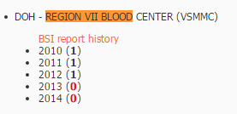Click **Ctrl + F** in the keyboard

then this search box will appear

on the upper right corner of

the browser – in the example

we typed *`Region VII Blood`*

once it found a match it will give

the user the result

* 1. 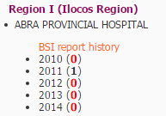Here is an example of a Blood

Safety Facility (*ABRA PROVINCIAL*

*HOSPITAL*) in its respective

Region (*REGION I (ILOCOS REGION))*

together with its BSI Report history

Note: **0** means it has NO official BSI

Report on that year.